Title

Author's Name & Surname1,*, Co-author's Name & Surname2

1 Author’s affiliation

2 Co-Author’s affiliation

* Corresponding Author’s information (e-mail: myname@maildomain.com)

Abstract

The Abstract should not normally exceed 250 words and should be written as a single paragraph. It must clearly state the principal objectives and scope of the investigation, along with the methodology employed. The Abstract should summarize the key results, highlight the principal conclusions, and emphasize the novelty of the research. An effective abstract should stand on its own, making it understandable to a broad audience even when read independently of the full paper. To achieve this, avoid referencing figures, tables, equations, or the bibliography in the abstract. The use of acronyms should also be avoided where possible. If acronyms are necessary, they must be defined the first time they appear in the abstract and again in the main text of the paper. Finally, include 4 to 6 significant keywords following the abstract to enhance the discoverability of your paper.

**Keywords:** keyword, keyword, keyword, keyword, keyword

1. Copyright

There is no Copyright claim on the proceedings of the ICAMPP conference. The proceedings are not considered as archival publications. The main purpose of the proceedings is to promote in-depth discussions and collaborations during and after the ICAMPP.

1. MAnuscript

Four-page papers are accepted and will be peer-reviewed by the scientific committee members. Authors of papers selected by Scientific Committee Chairs will be invited to extend the manuscripts and submit them to the thematic issue of Strojniški vestnik – Journal of Mechanical Engineering (IF 1.7) (open access).

Use a dedicated format of text, headings, captions, etc. as provided in this template. Note that the names of the styles you may use start with SV-JME, e.g. SV-JME Manuscript Text. The manuscript must be submitted to PaperCept (<https://controls.papercept.net/>) to 2025 International conference on Additive Manufacturing and Post-processing (ICAMPP) in the PDF format.

1. Subtitle

You may organize the body of your paper into subsections, which should be numbered with a prefix indicating the corresponding section number.

Sub-subtitle

You may further divide the body of your paper into sub-subsections. Sub-subsection should not be numbered.

1. Symbols and Units

The SI system of units for nomenclature, symbols and abbreviations should be followed closely. Symbols for physical quantities within the text and equations should be written in italics (e.g., *v*, *T*, *n*), indices should be written in upright style (e.g., *v*ref, *T*o, *n*i), unless referring to the physical quantity, while vectors and matrices should be written in bold. See Eq. (2) for details. Symbols for units that consist of letters should be in plain text (e.g. m s-1, K, min, W m-2). For further details and guidelines, please follow the link: [*http://physics.nist.gov/cuu/pdf/sp811.pdf*](http://physics.nist.gov/cuu/pdf/sp811.pdf)*.*

1. Abbreviations

Abbreviations should be spelt out in full on first appearance followed by the abbreviation in parentheses, e.g., variable time geometry (VTG). The meaning of symbols and units belonging to symbols should be explained in each case or cited in a nomenclature section at the end of the manuscript before the References.

1. Figures

* Figures, including diagrams, technical drawings, illustrations, photographs, and other artwork, must be cited in the text in consecutive numerical order (e.g., Fig. 1, Fig. 2, etc.) and referred to in both the text and captions.
* Figures should be prepared without borders and placed on a white background.
* If a figure consists of multiple parts, each part should be labeled with a), b), c), etc., and an explanation for each part should be included in the caption.
* Captions must be self-explanatory, with no strict length limitation.

Ensure that all letters and numbers within figures are legible, using Arial or Times New Roman fonts with a recommended size of 6–10 pt. Consistent font types and sizes should be maintained across all manuscript figures.

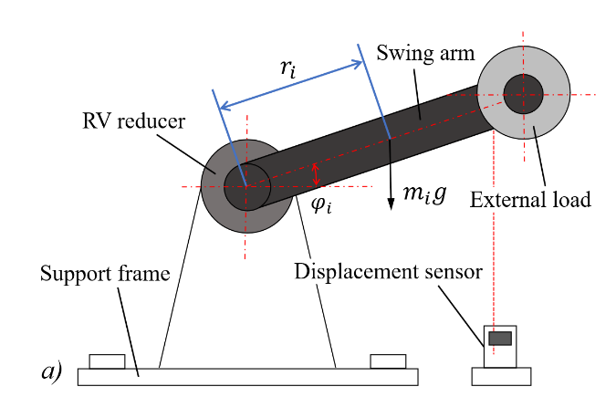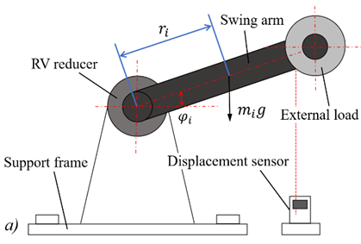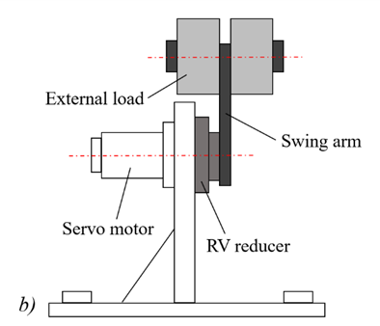

**Fig. 1.** A figure caption; a) explanation of part a; and b) explanation of part b

In addition to embedding figures at appropriate locations within the text, authors should also submit them separately in their original file formats (e.g., TIFF, BMP, GIF, JPG, or PDF) with a minimum resolution of 300 dpi. Graphs and line drawings should be prepared and uploaded as vector images (e.g., CDR, AI, or EMF). Avoid using print screens, and do not create multipart figures using MS Word canvas functionality.

1. Tables

Tables should carry separate titles and must be numbered in consecutive numerical order in the text and referred to in both the text and the captions as Table 1, Table 2, etc. Tables should not duplicate data found elsewhere in the manuscript. Tables should be prepared using a table editor as editable text and not inserted as a graphic. Units should be placed within square brackets, as shown in Table 1.

**Table 1.** Table title

|  |  |  |  |
| --- | --- | --- | --- |
| LDF | Line defects | Point defects | Precision [%] |
| Real quantity | 86 | 214 | 92.7 |
| Number of true positives | 65 | 213 |
| Number of false positives | 21 | 1 |

1. Equations

* Equations should be numbered in consecutive numerical order with the use of brackets in the text and referred to in the text as Eq. (1), Eq. (2), etc.
* The MS Word equation editor (LaTex editor) or MathType should be used for composing equations.
* Physical quantities and variables (such as *t*) should be in italics.
* Matrixes, vectors and tensors, such as one in Eq. (2), should be written in bold.
* Standard constants and indices should be written in an upright style, unless referring to the physical quantity (e.g., c1 and c*p*).

 (1)

 (2)

1. Decimal Notation

A period/full stop is used as the decimal point (3.14 instead of 3,14). The precision of numerical values should align with the level of uncertainty.

REFERENCES

Citations within the manuscript and references in the reference section should be indicated using sequential numbers in square brackets (e.g., [1] or [2, 3] or [4-6]), assigned in the order they appear in the text. Every reference cited in the manuscript must be included in the reference list, and all entries in the reference section must be cited in the manuscript. Ensure that all references are complete and accurate. Whenever possible, include the DOI for each reference. Non-English references must be given in English translation with a concluding comment on the language of the reference, for example, “(in Polish)” after the reference.

A list of references must be included using the following examples as a guide. EndNote citation style is available on Guide for Authors web page: <https://www.sv-jme.eu/guide-for-authors-online/>

Journal Papers

Surname 1, Initials, Surname 2, Initials. Title. *Journal* **volume**, pages (year) **DOI: code**

Note that *Journal Title* is set in italics and abbreviated based on WoS@Caltech list of abbreviations: [https://library.caltech.edu](https://library.caltech.edu/c.php?g=512744&p=4327657).

[1] Hackenschmidt, R., Alber-Laukant, B., Rieg, F. Simulating nonlinear materials under centrifugal forces by using intelligent cross-linked simulations. *Stroj Vestn-J Mech E* **57**, 531-538 (2011) **DOI: 10.5545/sv-jme.2011.013**

Books

Surname 1, Initials, Surname 2, Initials. *Title*. Publisher (year) Place of publication

Note that the *Title of the Book* is italicized.

[2] Groover, M.P. *Fundamentals of modern manufacturing*. Wiley (2021) Hoboken

Book Chapters

Surname 1, Initials, Surname 2, Initials. Chapter title. EditorSurname 1, Initials, EditorSurname 2, Initials(ed(s).), *Book title*. Publisher (year) Place of publication, p. pages

Note that the *Book title* is italicized.

[3] Zupančič, M., Gregorčič, P. Laser surface engineering for boiling heat transfer applications. Hosseini, M., Karapanagiotis, I. (eds.), *Materials with extreme wetting properties: Methods and emerging industrial applications*. Springer (2021) Cham, p. 245-303

Proceedings Papers and Conference Papers

Surname 1, Initials, Surname 2, Initials. Paper title. *Proceedings title* or *Conference Name* (year) p. pages

Note that the *Proceedings Title* or *Conference Name* is italicized.

[4] Štefanić, N., Martinčević-Mikić, S., Tošanović, N. Applied lean system in process industry. *MOTSP Conference Proceedings* (2009) p. 422-427

Standards

Standard-Code (Rule Number). *Title*. Organisation (year) Place of publication

Note that the *Title of the* *Standard* is italicized.

[4] ISO 16573-2:2022. *Steel - measurement method for the evaluation of hydrogen embrittlement resistance of high-strength steels*. International Organization for Standardization (2022) Geneva

Web pages

Publisher or Company or Authors (Surname, Initials). Title. *URL*, accessed on: YYYY-MM-DD

Note that the *URL* is italicized.

[5] Strojniški vestnik-Journal of Mechanical Engineering. Guide for authors online. [*https://www.sv-jme.eu/guide-for-authors-online/*](https://www.sv-jme.eu/guide-for-authors-online/), accessed on 2024-12-04

Acknowledgements

(Optional). Authors should disclose the funding sources that supported the research conducted. Other acknowledgments, such as collaborations or assistance with the preparation of the manuscript, may also be included here.